***Circulation Classwork*** Name ___________________________

Classwork #2

6th Grade PSI

1. You walk into class to see your teacher at the front of the room about to do a demonstration. She has one container of ice water, dyed blue, and one container of hot water, dyed red.
   1. Explain what will happen if she pours the red liquid on top of the blue liquid? Why?

_________________________________________________________________________________________________________________________________________________________________________________

* 1. Explain what will happen if she pours the blue liquid on top of the red liquid? Why?

_________________________________________________________________________________________________________________________________________________________________________________

1. On a hot summer day, you and your friends decide to go on a trip to the beach. As you park in an asphalt parking lot, you realize that you forgot to wear shoes! In order to get to the cool, ocean water, you first have to walk across the asphalt and then the sand. As a brilliant science student, you remember that asphalt has a heat capacity of 0.920 while sand has a heat capacity of 0.835.
   1. Which surface will feel hotter to your bare feet? Explain your answer.

_________________________________________________________________________________________________________________________________________________________________________________

* 1. Even though the sun is shining equally on the asphalt, the sand and the ocean, the ocean will feel cool while the sand and asphalt will feel hot. Explain this.

_________________________________________________________________________________________________________________________________________________________________________________

***Circulation Homework*** Name ___________________________

Homework #2

6th Grade PSI

1. Look at the map of prevailing winds below. Locate one country that receives prevailing winds that carry a lot of moisture. Put a red dot on this country. Locate one country that receives prevailing winds that are very dry. Put a green dot on this country.

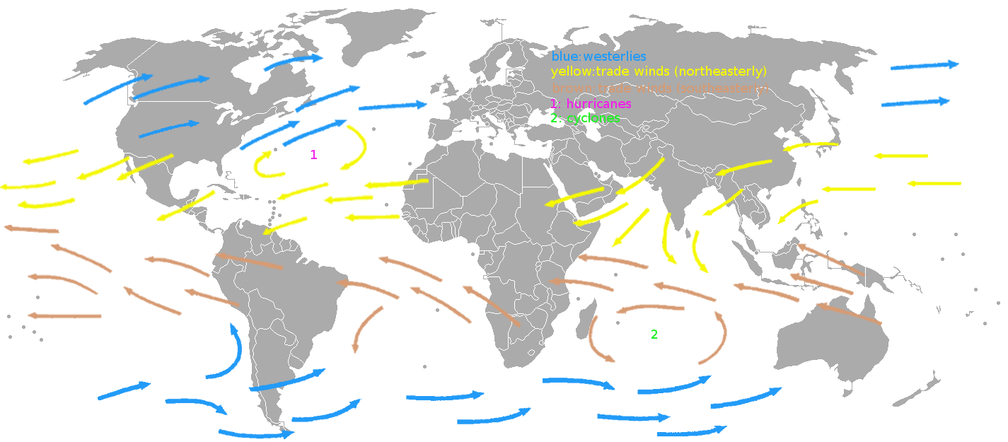

1. Some air masses are warm while others are cold. Describe how each type of air mass can carry different amounts of moisture with them.

________________________________________________________________________________________________________________________________________________________________________________________________

1. Oceans are an important aspect of regulating Earth’s climate and weather.
   1. Describe how oceans regulate climate.

_________________________________________________________________________________________________________________________________________________________________________________

* 1. Describe how oceans affect weather.

_________________________________________________________________________________________________________________________________________________________________________________

***Geography Classwork*** Name ___________________________

Classwork #3

6th Grade PSI

1. For every 1,000 feet increase in altitude, temperature drops by about 4⁰F. If the temperature at the base of a mountain is 75⁰F, what is the temperature 10,000 feet higher at the top of the same mountain?

________________________________________________________________________________________________________________________________

1. You are sunbathing on the beach on a warm, summer day. Describe the type of breeze you will probably feel. Why does this breeze form?

________________________________________________________________________________________________________________________________________________________________________________________________________________________________________________________________________________________________________________________________

1. You are camping in a valley beside a hill. During the night, what type of breeze will you probably feel? Why does this breeze form?

________________________________________________________________________________________________________________________________________________________________________________________________________________________________________________________________________________________________________________________________

***Geography Homework***  Name ___________________________

Homework #3

6th Grade PSI

Listed below are pairs of locations. Describe how the weather or climate would differ between the two locations.

1. The Midwest versus Virginia Beach

________________________________________________________________________________________________________________________________________________________________________________________________

1. The windward side of a mountain range (the side where wind blows from) versus the leeward side of a mountain range

________________________________________________________________________________________________________________________________________________________________________________________________

1. Land directly beside a glacier versus land at the same latitude but with no glacier

________________________________________________________________________________________________________________________________________________________________________________________________

***Weather Prediction Classwork*** Name ___________________________

Classwork #4

6th Grade PSI

Determine whether each description is characteristic of high pressure or low pressure.

1. _________________________ Cool, dry air.
2. _________________________ Storms and strong winds.
3. _________________________ Fair weather and light winds.
4. _________________________ Warm, moist air.

Determine whether each description is characteristic of a cold or warm front.

1. _________________________ Warm air replaces cold air.
2. _________________________ Brings low pressure.
3. _________________________ Brings lower temperatures.
4. Based on the weather map, what weather should the following locations expect?

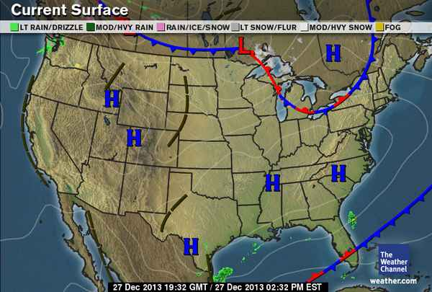

Tennessee

Maine

Maine:

Tennessee:

***Weather Prediction Homework*** Name ___________________________

Homework #4

6th Grade PSI

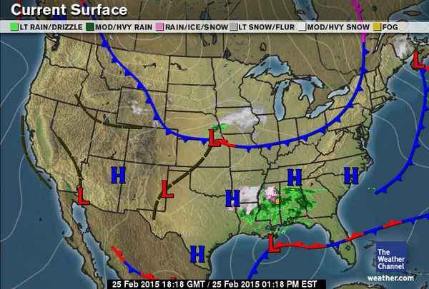Below are three weather maps that show information for the same time period.

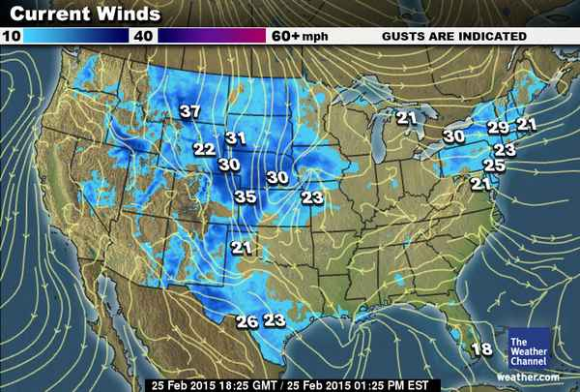

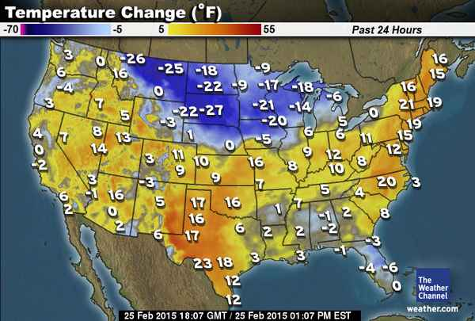

1. On the Current Surface map, focus on the northern Midwest. Based on the information on this map, how can you explain the same area on the Current Winds map?

________________________________________________________________________________________________________________________________________________________________________________________________________________________________________________________________________________________________________________________________

1. On the Current Surface map, focus on northern Texas. Based on the information on this map, how can you explain the Temperature Change map?

________________________________________________________________________________________________________________________________________________________________________________________________________________________________________________________________________________________________________________________________

***Natural Disasters Classwork*** Name ___________________________

Classwork #5

6th Grade PSI

**Hurricanes**

Engines of Destruction

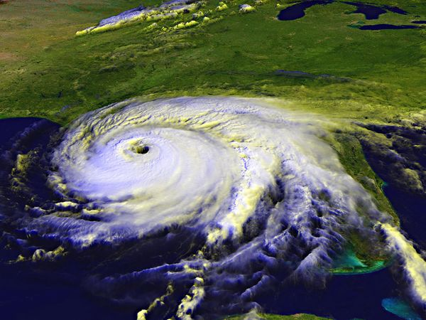

*Photograph courtesy NASA/GSFC*

Hurricanes are giant, spiraling tropical storms that can pack wind speeds of over 160 miles (257 kilometers) an hour and unleash more than 2.4 trillion gallons (9 trillion liters) of rain a day. These same tropical storms are known as cyclones in the northern Indian Ocean and Bay of Bengal, and as typhoons in the western Pacific Ocean.

The Atlantic Ocean’s hurricane season peaks from mid-August to late October and averages five to six hurricanes per year.

Hurricanes begin as tropical disturbances in warm ocean waters with surface temperatures of at least 80 degrees Fahrenheit (26.5 degrees Celsius). These low pressure systems are fed by energy from the warm seas. If a storm achieves wind speeds of 38 miles (61 kilometers) an hour, it becomes known as a tropical depression. A tropical depression becomes a tropical storm, and is given a name, when its sustained wind speeds top 39 miles (63 kilometers) an hour. When a storm’s sustained wind speeds reach 74 miles (119 kilometers) an hour it becomes a hurricane and earns a category rating of 1 to 5 on the Saffir-Simpson scale.

Hurricanes are enormous heat engines that generate energy on a staggering scale. They draw heat from warm, moist ocean air and release it through condensation of water vapor in thunderstorms.

Hurricanes spin around a low-pressure center known as the “eye.” Sinking air makes this 20- to 30-mile-wide (32- to 48-kilometer-wide) area notoriously calm. But the eye is surrounded by a circular “eye wall” that hosts the storm’s strongest winds and rain.

These storms bring destruction ashore in many different ways. When a hurricane makes landfall it often produces a devastating storm surge that can reach 20 feet (6 meters) high and extend nearly 100 miles (161 kilometers). Ninety percent of all hurricane deaths result from storm surges.

A hurricane’s high winds are also destructive and may spawn tornadoes. Torrential rains cause further damage by spawning floods and landslides, which may occur many miles inland.

The best defense against a hurricane is an accurate forecast that gives people time to get out of its way. The National Hurricane Center issues hurricane watches for storms that may endanger communities, and hurricane warnings for storms that will make landfall within 24 hours.

Source: <http://environment.nationalgeographic.com/environment/natural-disasters/hurricane-profile/>

Questions

1. From where do hurricanes get their energy?

________________________________________________________________________________________________________________________________

1. What must a storm have before it can be classified a hurricane?

________________________________________________________________________________________________________________________________

1. What are two different ways that hurricanes cause damage?

________________________________________________________________________________________________________________________________________________________________________________________________________________________________________________________________

1. Critical Thinking: Why would hurricanes form over warm ocean water instead of cool ocean waters?

________________________________________________________________________________________________________________________________________________________________________________________________________________________________________________________________

***Natural Disasters Homework*** Name ___________________________

Homework #5

6th Grade PSI

|  |  |
| --- | --- |
| |  | | --- | | **Tornadoes are Earth's most violent storms** | |
| Tornadoes are the most violent storms on Earth. Winds spiraling into them usually exceed 100 mph and can reach speeds of 300 mph. In the USA, an average of 1,000 tornadoes spin up beneath thunderstorms each year, and these typically kill about 60 people.  Tornadoes and the threat of tornadoes are a key part of the USA's spring weather because spring brings favorable tornado conditions. But tornadoes can occur any time of the year, during the day and at night.  The National Weather Service defines a tornado as "a violently rotating column of air in contact with the ground and pendant from a thunderstorm." In other words, a thunderstorm is the first step in the creation of a tornado. Then, if other conditions are right, the thunderstorm might spin out one or more tornadoes.  The three key conditions required for thunderstorms to form are:  • Moisture in the lower to mid levels of the atmosphere.  • Unstable air. That is, air that will continue rising once it begins rising from near the ground.  • A lifting force. Something is needed to cause the air to begin rising. The most common lifting force is heating of air near the ground. As the air warms it becomes lighter and begins rising. Advancing masses of cool air, which force warm air upward, also trigger thunderstorms.  When all the conditions are present, humid air will rise high into the sky and cool and condense into towering clouds, forming thunderstorms. This air rising into a thunderstorm is called an updraft. Tornadoes form in within a thunderstorm's updraft.  The strongest tornadoes are often near the edge of the updraft, not far from where air is descending in a downdraft caused by the thunderstorms with falling rain or hail. This is why a burst of heavy rain or hail sometimes announces a tornado's arrival.  Tornadoes are commonly associated with the nation's heartland – in a 10-state area stretching from Texas to Nebraska that also includes Colorado, Iowa, Illinois, Indiana, Missouri and Arkansas, known as Tornado Alley.  But, they are not limited to this region. Tornadoes have occurred in all 50 U.S. states and are, in fact, more common in Florida than they are in Oklahoma.  Florida tornadoes are generally weak — for tornadoes — with winds around 100 mph.  Tornadoes that have hit Oklahoma, on the other hand, are some of the most violent on record. A tornado that struck Oklahoma City and its southern suburbs in 1999 had winds of nearly 320 just above the ground.  Tornadoes are ranked by the damage they do using the six-tiered Fujita Scale. F0 and F1 tornadoes on the scale are considered "weak" and cause minimal to moderate damage with winds from 40-112 mph. F2 and F3 tornadoes are considered strong, packing winds of 113-206 mph that can cause major to severe damage. Violent tornadoes are those classified F4 and F5 with winds exceeding 206 mph. Damage is extreme to catastrophic.  Most weak tornadoes last 10 minutes or less, traveling short distances. Violent tornadoes have been known to last for hours and a few have traveled more than 100 miles. |

Source: <http://usatoday30.usatoday.com/weather/resources/2006-04-03-tornado-basics_x.htm>

1. What is the first step in the creation of a tornado?

________________________________________________________________________________________________________________________________

1. What is an updraft?

________________________________________________________________________________________________________________________________

1. Where do strong tornadoes form?

________________________________________________________________________________________________________________________________

1. In what state or tornadoes most common?

________________________________________________________________

1. According to the Fujita Scale, what is the most violent tornado?

________________________________________________________________

1. Critical Thinking: Why do most violent tornadoes occur in Tornado Alley?

________________________________________________________________________________________________________________________________________________________________________________________________________________________________________________________________

**Answer Key**

**Global Warming Worksheet**

* 1. The amount of sea ice is decreasing.
  2. Increased CO2 in the atmosphere traps in heat, raising the temperature of Earth. The warmer temperatures causes the sea ice to melt.
  3. Sea level is rising.
  4. Increased CO2 causes the temperature of Earth to rise. As sea ice melts due to higher temperatures, this causes the sea level to rise.
  5. The amount of precipitation is increasing.
  6. Increased CO2 causes the temperature of Earth and oceans to rise. As ocean water warms, it evaporates more easily. This creates storms as the evaporated water condenses into clouds and then falls as precipitation.

**Sunlight and the Atmosphere Classwork**

Classwork #1

1. Latitude
2. Electromagnetic
3. Tropical
4. Indirect
5. Tilt
6. Infrared
7. Polar
8. Weather
9. Climate
10. Weather

**Sunlight and the Atmosphere Homework**

Homework #1

1. Tropical
2. Polar
3. Temperate
   1. Electromagnetic (solar) energy. It comes from the sun.
   2. Infrared radiation
4. Electromagnetic energy hits the Earth from the sun. The Earth absorbs this energy. The Earth emits energy in the form of infrared radiation. Some of the infrared radiation escapes back into space. The remaining infrared radiation gets trapped in the atmosphere by greenhouse gases. This warms the Earth.

**Circulation Classwork**

Classwork #2

* 1. If she pours red on top of blue, nothing will happen. Warm water is less dense and will remain on top of the cold water, which is denser.
  2. If she pours blue on top of red, the blue water will sink to the bottom while the red water rises to the top. Since warm water is less dense, it will rise above the cold water which is denser.
  3. The sand will feel hotter on your bare feet. The sand has a lower heat capacity than the asphalt. Objects with lower heat capacities heat up faster than objects with higher heat capacities.
  4. Water has a very high heat capacity. This means that it can store a large amount of heat energy without experiencing a large increase in temperature. The other objects, asphalt and sand, have lower heat capacities. This means that all of the objects absorb the same amount of heat energy but the objects with lower heat capacities heat up faster.

**Circulation Homework**

Homework #2

1. Answers will vary.
2. Warm air can carry more moisture than cold air. Warm air is less dense than cold air. This means that the molecules in warm air are more spread out and there is room to carry water molecules. Cold air is very dense and the molecules are very close together. There is not much room to carry water molecules.
   1. Oceans store a lot of heat and are a source of moisture. As ocean currents travel around the world, they distribute this heat and moisture, thereby regulating climate.
   2. Oceans are a source of water molecules for evaporation in the water cycle. The water later condenses into clouds and falls as precipitation. In this way, oceans contribute to local weather.

**Geography Classwork**

Classwork #3

1. 35⁰F
2. During the day, the land heats up faster than the ocean. The warm, less dense air over the land (beach) rises and air from over the ocean moves over to take its place. You will feel this as a breeze moving from the ocean towards the land.
3. During the night, the hilltop will cool off faster than the valley. The warm, less dense air over the valley will rise while cool, denser air from the hill sinks into the valley. You will feel this as a breeze moving from the hill down to the valley.

**Geography Homework**

Homework #3

1. The Midwest will be cooler in the winter and warmer in the summer than Virginia Beach because the ocean at Virginia Beach moderates the temperature.
2. The windward side of a mountain will be wet while the leeward side will be dry. As air moves up the windward side, the air cools and condenses, causing precipitation. As it moves over to the leeward side, the air has lost its moisture and is very dry.
3. The land right next to the glacier will be much cooler. Glaciers reflect sunlight instead of absorbing it, making the temperature near glaciers cooler.

**Weather Prediction Classwork**

Classwork #4

1. High
2. Low
3. High
4. Low
5. Warm
6. Warm
7. Cold
8. Maine: They are about to be hit by a cold front so they will experience storms followed by cold, drier weather from the high pressure that follows. Tennessee: They are experiencing a high pressure system so they are having fair weather with light winds.

**Weather and Prediction Homework**

Homework #4

1. This area just experienced a cold front. As a cold front passes, it causes strong winds. That is why this area shows strong winds on the map.
2. Northern Texas is experiencing a low pressure system. These bring warm, wet weather. That is why this area shows a temperature increase.

**Natural Disasters Classwork**

Classwork #5

1. Hurricanes get their energy from warm ocean water.
2. A storm must have winds of at least 74 mph before it is classified a hurricane.
3. Hurricanes can cause damage due to storm surge and tornadoes.
4. Warm water is required in order for enough evaporation to occur that will create strong storms.

**Natural Disasters Homework**

Homework #5

1. A thunderstorm is the first step in the creation of a tornado.
2. An updraft is the air rising into a thunderstorm.
3. Strong tornadoes form in the edge of an updraft.
4. Florida has the most tornadoes.
5. An F5 is the strongest tornado.
6. The clash of cold air from the north and warm air from the south creates intense thunderstorms in this area that go on to form tornadoes.